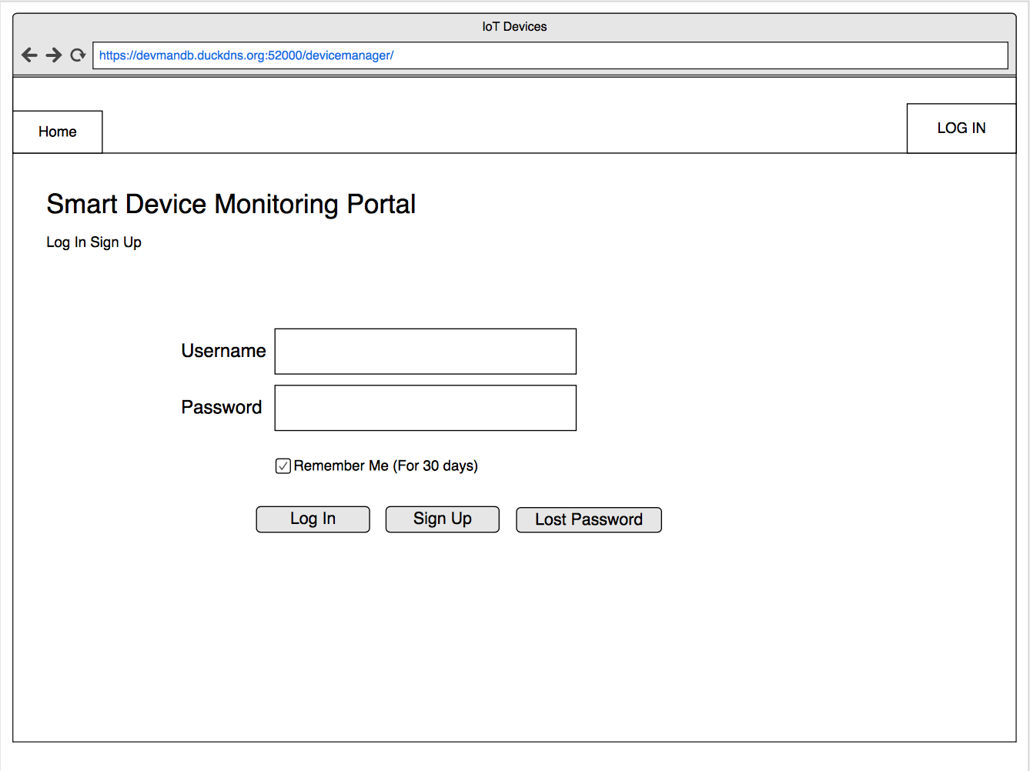This document is postproduction plans containing Wireframes to Lo-Fi prototype.

The image below contains a wireframe design of the Index page. This contains a Login and signup feature that’s allows users to take control of their account.

If the User does not have an account the option to sign up should be selected. Once selected the device prompts the user to fill in their details, once these actions are completed an account is created. We have designed the page with minimalistic aspirations so the user can navigate around the page with ease.

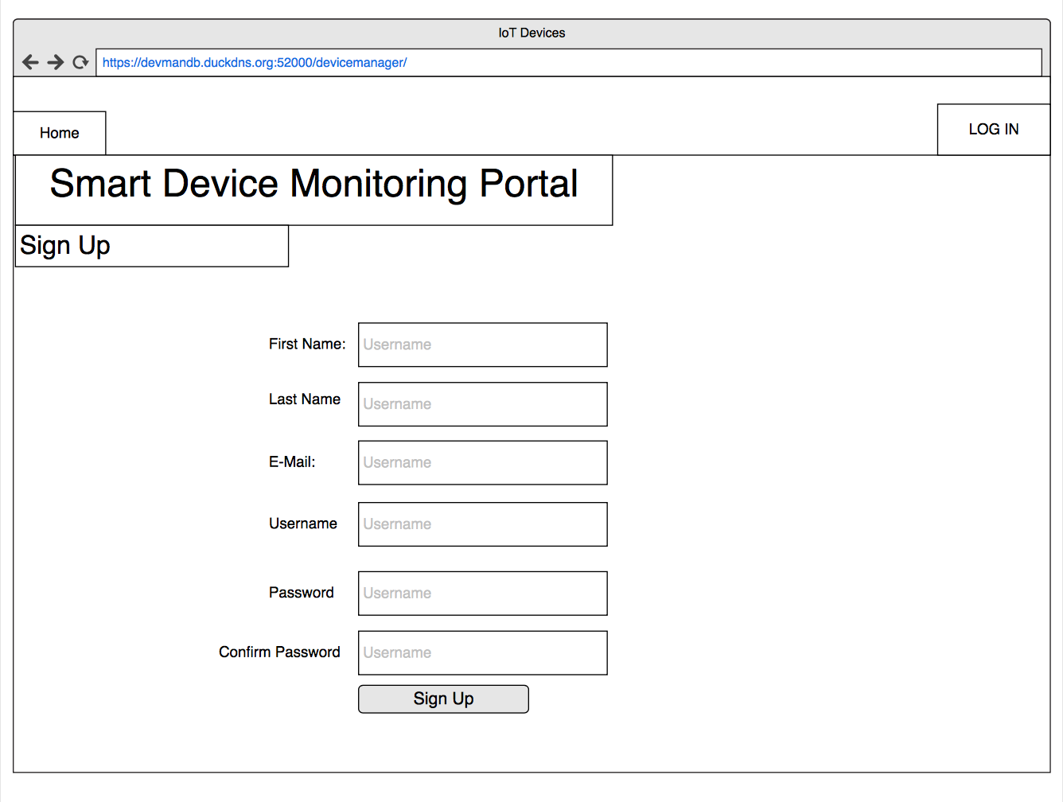

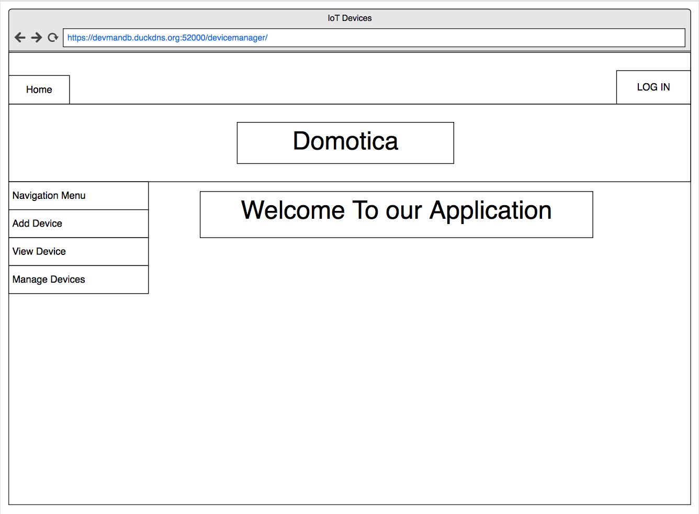Once Signed up or logged in the account page is displayed. We have also chosen a minimalistic design for ease of use for the user. In these pages we have two navigations panes, top nav and side nav. Top nav is used to navigate to the home page and to check your profile details. The side nav is used to navigate through the device features, Add device, View Device and Manage device.

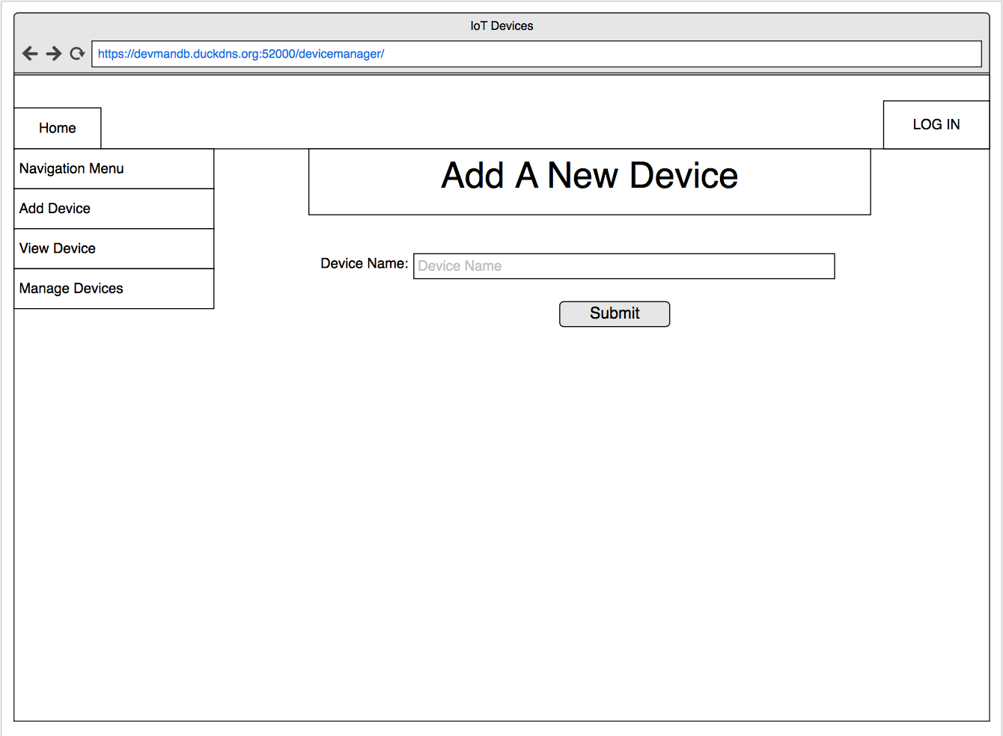Once Add Device is selected this page is shown. This page contains a feature to add new devices to your device list.

This image shows the wireframes for the connected devices. Each device contains a status that could be OFF or ON. Once clicked on a device the statists of the device is then displayed.

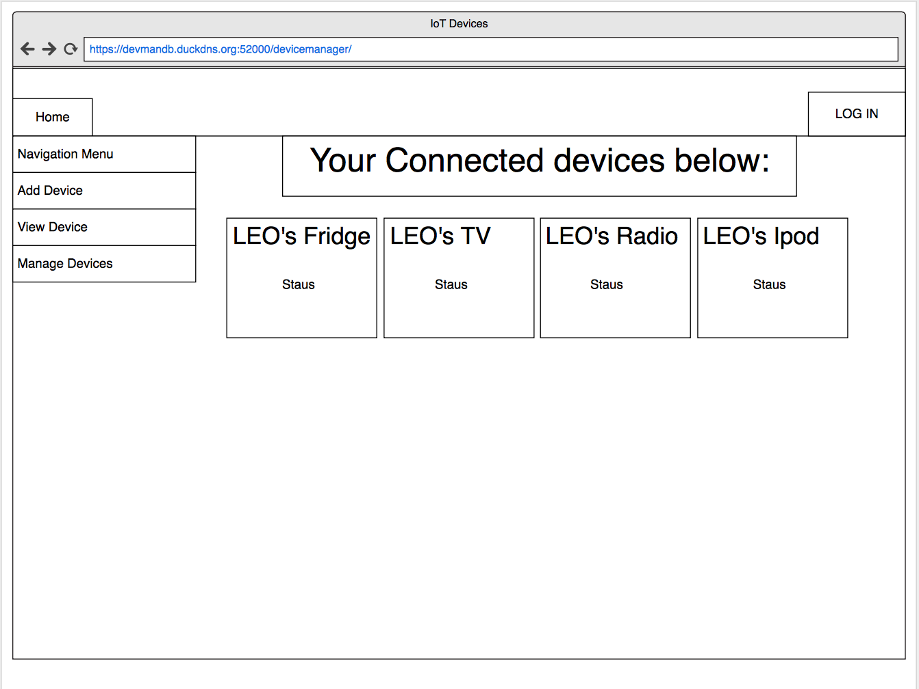

The figure below shows all the device statistics. On the right we will have graphs displaying the changes in temperature along the timeline. On the right side we have the device name that will show when the device was first connected to network.

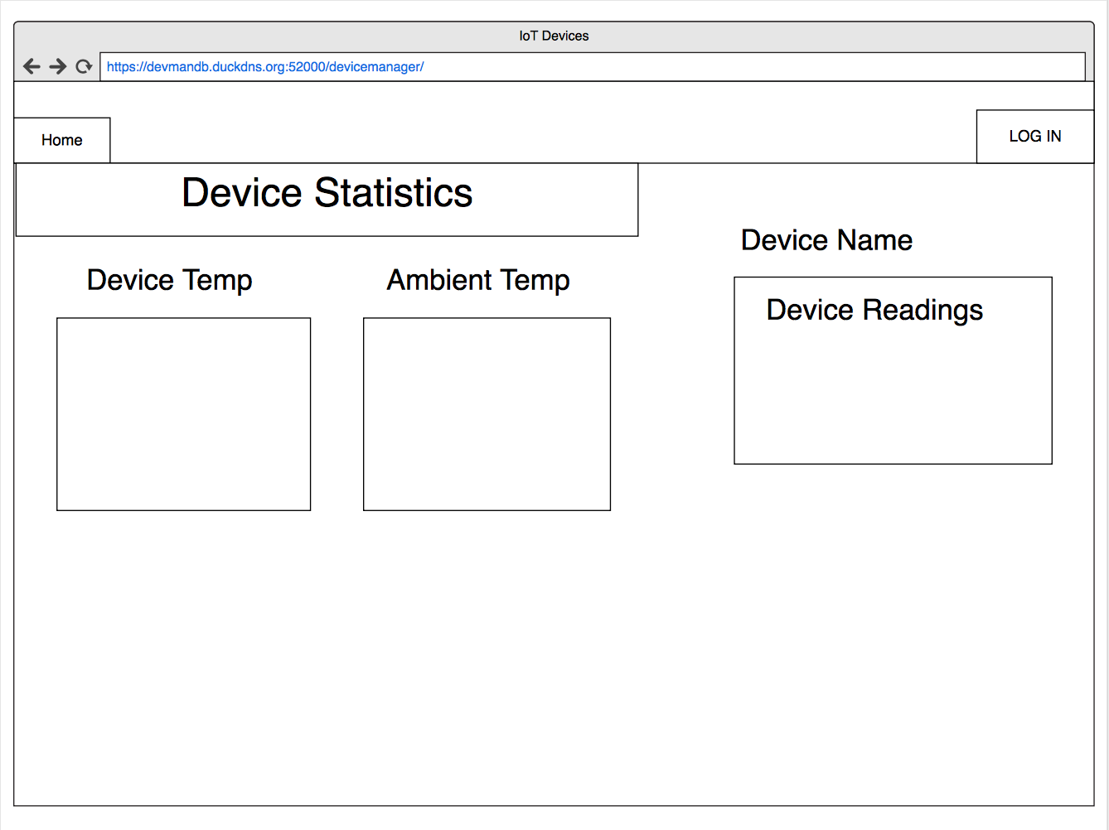

This figure shows the device management page. This was created to take control of devices, all devices are shown and the ability to edit view and delete is introduced. This page was created to create seamless functionality when managing devices.

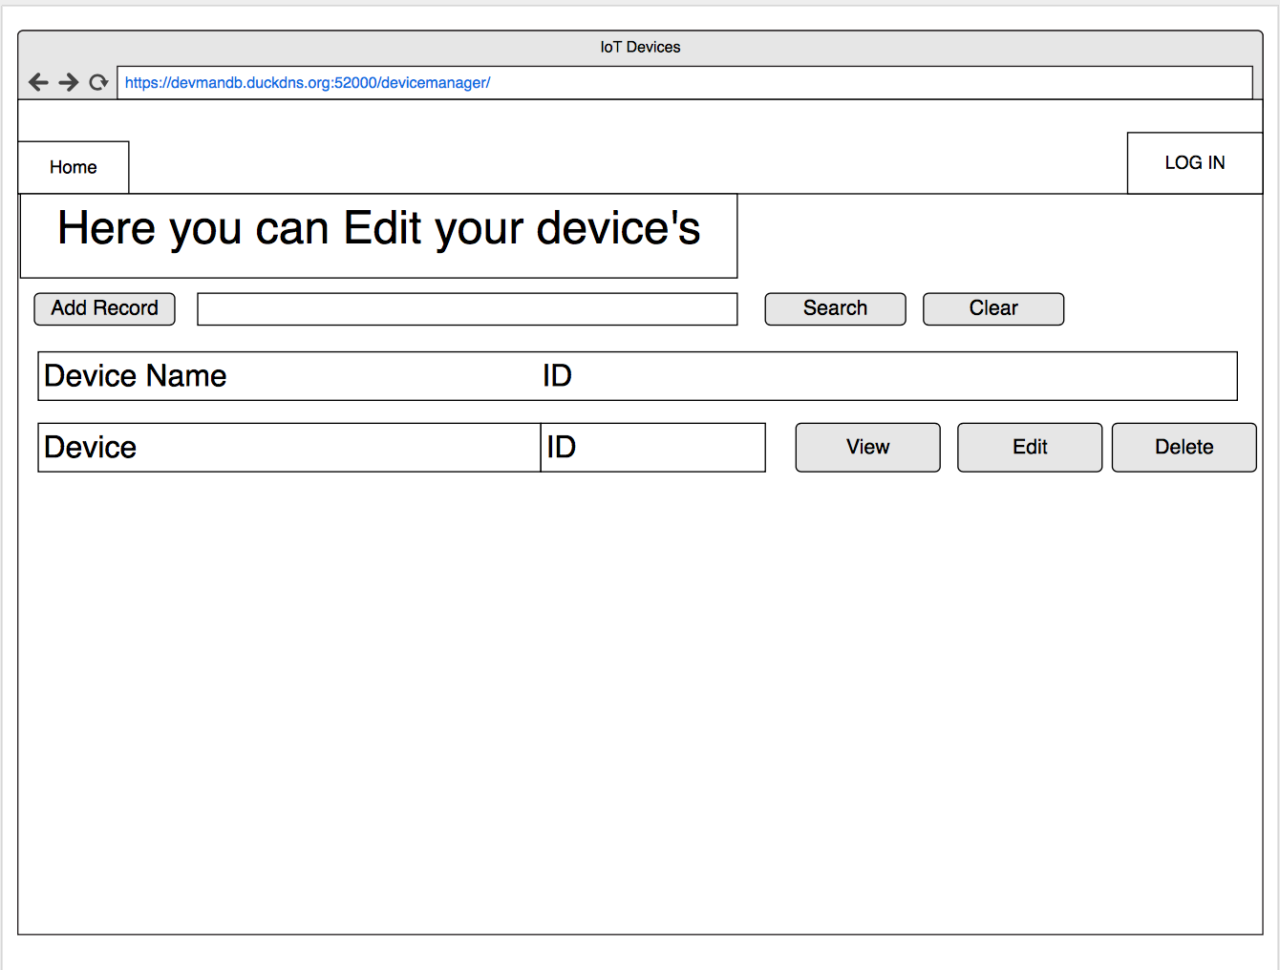

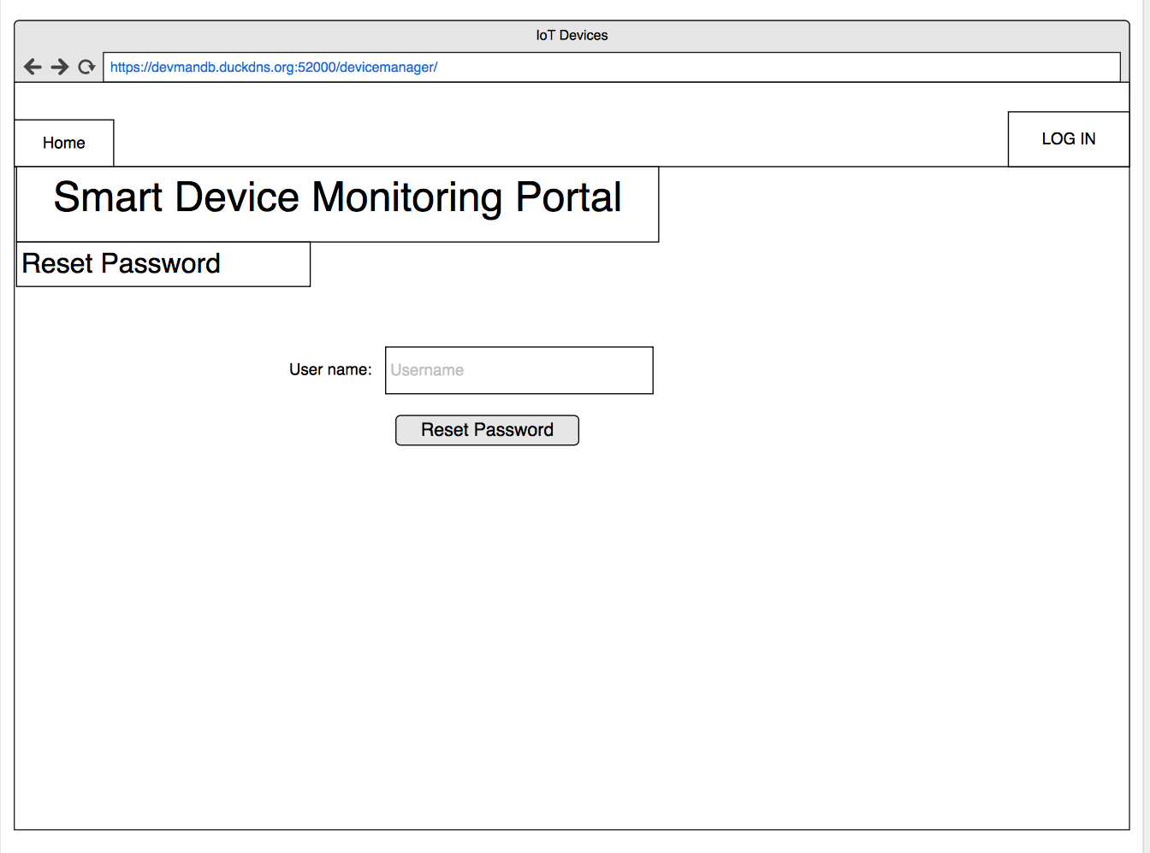This image shows the Reset password page. This page is used if the user forgets or misplaces his password he has the ability to change and reset their password. This feature is very important because the last thing we want is people being locked out of this service.

Shown bellow is the lo-fi prototype. This is built to aid designs for the front end; each button is a hyperlink to another page. This is one of the first highly detailed design concepts that we created using Photoshop. Once the Designs were created on Photoshop we then imported them into Invision. This is used to add hyperlinks to the prototype; this created a first look at our application in an dynamic format. These design reflect the wireframes. We went with a very minimalistic design using two main colours for the webpages. We went with this design to aid to all audiences and to abide with nelson heuristics.

